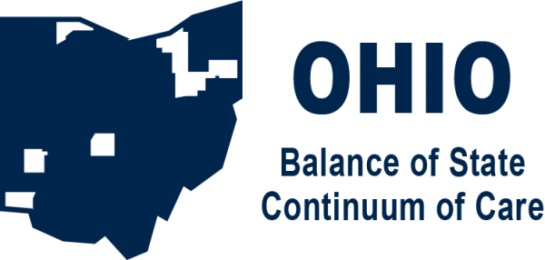

Request for Proposals: Youth Homelessness System Improvement Data Consultation for the Ohio Balance of State Continuum of Care

Purpose
The purpose of this Request for Proposals (RFP) is to obtain the professional services of a firm or individual, hereinafter referred to as the “Proposer”, to partner with the Ohio Balance of State Continuum of Care (BoSCoC) to gather and analyze system of care data that contribute to or prevent youth and young adult homelessness and provide a report with recommendations on policy and practice initiatives.

Background
Continuum of Care
A Continuum of Care (CoC) is a geographically based group of representatives that carries out the planning responsibilities required by the U.S. Department of Housing and Urban Development’s (HUD) CoC Program. These representatives generally come from organizations that provide services to persons experiencing homelessness and entities that collaborate with homeless service providers to comprehensively strategize around addressing and ending homelessness within the CoC’s geographic area.

The Ohio Balance of State Continuum of Care
The Ohio Balance of State Continuum of Care represents the 80 largely suburban and rural counties in Ohio. Within these 80 counties there are approximately 400 homeless programs including emergency shelters, transitional housing, rapid re-housing programs, and permanent supportive housing. On any given day, these programs can serve over 7,700 persons experiencing homelessness.

Ohio Balance of State Continuum of Care Homeless Planning Regions
The 80 counties within the Ohio BoSCoC are divided into 17 Homeless Planning Regions Homeless program representatives in these Homeless Planning Regions plan and coordinate local homeless systems and programs and are responsible for working with the Ohio Department of Development, Office of Community Development (ODOD) and COHHIO to ensure the requirements of both their federal grant (HUD’s CoC Program) and state grants (ODOD’s ESG, HAGP, HCRP, and SHP).

COHHIO and the YHSI Grant
The Coalition on Homelessness and Housing in Ohio (COHHIO) provides primary staff support for all activities pertaining to the Ohio BoSCoC. COHHIO’s Continuum of Care Director and Coordinators are the primary contacts for all Ohio BoSCoC work. As the Homeless Management Information System (HMIS) Lead and System Administrator, COHHIO staff also support all aspects of the CoC’s HMIS implementation.

In 2024, the U.S. Department of Housing and Urban Development (HUD) awarded the Coalition on Homelessness and Housing in Ohio $2,000,000 through the Youth Homelessness Systems Improvement (YHSI) grant to address youth homelessness. This grant supports six of Ohio’s nine CoCs in improving the holistic system of care for young people (up to age 25) at risk of or experiencing homelessness and housing instability, with a particular focus on youth exiting foster care and youth exiting involvement with the justice system. There are three categories of work that will be conducted as part of the grant: planning and partnerships, coordinated entry, and data. YHSI activities are intended to build upon previous work done through the Youth Homelessness Demonstration Program in Ohio’s awarded communities; in the BoS that includes Homeless Planning Regions 2, 3, 5, 6, 9, 11, 14, and most of 17.

Objectives and Desired Outcomes

- Identify key functions in the Balance of State (BoS) system of care (K-12 and post-secondary education, workforce development, health, child welfare, mental health, and juvenile justice) that either mitigate (provide protection from) or contribute to (make more vulnerable/susceptible) a young person’s experiencing homelessness. See scope of work for task-level expectations.

- Prepare a comprehensive report detailing findings and offering policy and/or practice recommendations in the system of care to decrease vulnerability to housing insecurity and increase access to housing stability.

As a result of these two objectives, the BoS should be able to

- Draft and implement (or advocate for state-level) policy or practices to elevate protections and decrease vulnerabilities in the system of care
- Support youth-led oversight to ensure policy and practice initiatives are implemented and monitored
- Identify the most strategic locations for new youth-dedicated housing projects to reduce homelessness in special populations: those exiting foster care; those exiting juvenile justice; and multi-system youth.

Geography included in this scope of work
The 80 counties of the Ohio Balance of State Continuum of Care, with special attention where applicable to its YHDP-awarded communities (Homeless Planning Regions 2, 3, 5, 6, 9, 11, 14, and 17).

Budget
Not to exceed $50,000

Timeline

Date
October 29, 2025 | RFP published
Until November 20, 2025 | Questions accepted, answers posted to https://cohhio.org/boscoc/special-initiatives/
November 24, 2025 | Proposals due
By December 12, 2025 | Consultant selected
By December 30, 2025 | Finalize contract
January 5, 2026 | Begin work
June 30, 2026 | Deliver final report

Expected Tasks

- Hold regular check in meetings with designated BoSCoC staff and Youth Action Board members to track progress on project

- Confirm and complete existing system map of all youth-dedicated housing resources in the BoSCoC (Both CoC and non-CoC funded, see appendix)
- YHDP TH
- YHDP RRH
- PSH
- ES
- ODH-funded housing resources
- Youth recovery housing
- Other RHY and TAY housing (e.g., Transition to Independence (TIP) houses, Transitional Living Programs (TLP))
- Others

- Analyze Ohio Department of Children and Youth data (2022-2025) for exits to homelessness from foster care in BoSCoC counties. Determine if any county-or region-level coordination processes exist and are utilized that effectively prevent young adults exiting to homelessness after aging out of foster care.

- Analyze Ohio CCMEP and WIOA data (2022-2025) for BoSCoC counties to determine where housing/homelessness is a barrier to education or employment for more than 10% of participants. Identify counties where housing insecurity is not a barrier to education or employment (impacts less than 5% of participants) and select one or two to interview to learn more.

- Analyze Ohio Department of Youth Services data, if available, (2022-2025) for exits to homelessness in BoSCoC counties. Determine if any county-or region-level reentry processes exist and are utilized that effectively prevent young adults exiting to homelessness after incarceration.

- Analyze Ohio Department of Health Community Health Improvement Plans (2020-2025 or most recent) from BoSCoC counties to identify and catalog Social Determinants of Health (SDOH) – housing and/or homelessness action plans (which counties/health districts have a plan, what action items are in the plan, what community partners are engaged in fulfilling the plan) and/or SDOH plans in BoSCoC counties to address youth homelessness or housing instability

- Find and analyze eviction data (2022-2025) in BoSCoC counties to see where young adults (under age 25) are being evicted and at what rate.

- Review NLIHC/COHHIO Out of Reach Data for (2022-2025) from BoSCoC counties to determine average rents and % increases over three years in the BoSCoC – resulting in one BoSCoC overview and 80 individual county profiles.

- Analyze Bureau of Labor Statistics data (and/or ODJFS) to determine the most prevalent job types and corresponding average salaries/income of young adults (ages 18-24) in the BoSCoC. Determine the requirements needed for jobs that pay housing wage, e.g., certifications, experience, degrees etc.

- Survey BoS counties to identify average childcare costs.

- Analyze Regional Coordinated Entry (CE) Plans of BoSCoC YHDP communities (2022-2025) to identify any youth-specific practices for access, prioritization, and referral.

- Identify national CE best practices in a BoSCoC and/or rural setting for ensuring young people can quickly access housing resources.

- Prepare and present a comprehensive report detailing findings and offering policy and/or practice recommendations in the system of care that decrease vulnerability to housing insecurity and increase access to housing stability for youth and young adults.

Qualifications

The Proposer must
- Have previous experience working with data related to housing and homelessness in similarly situated communities.
- Provide references from two previous clients for whom similar work was completed.
- Comply with applicable local, state and federal laws and regulations and meet applicable professional standards. Proof of insurance may be required at time of contracting.
- Be an equal opportunity employer and provide assurance that no person will be denied services on the basis of race, color, religion, sex (including gender identity, sexual orientation, and pregnancy), national origin, age (40 or older), disability or genetic information.

Preference will be given to proposers
- Whose detailed project plan provides hands-on opportunities for BoSCoC Youth Action Board members to gain more understanding of data collection and analysis. The BoSCoC will compensate YAB members for their time working on this project.
- With demonstrated previous experience working with data related to transition aged youth.
- With one or more Proposer team members with lived experience of homelessness or housing instability.

Submission Format and Due Date
The following should be compiled and submitted in one pdf document:

- A detailed work plan that describes how the Proposer will work with the BoSCoC to accomplish the scope of work.
- The work plan should include a description of processes to be used, deliverables, and timeframes for each objective with how the tasks in the scope of services will be completed.
- The timeline should indicate the length of time suggested for each activity and its beginning and ending point within the contract period.
- This work plan should also clearly articulate how the Proposer will ensure meaningful engagement with young people with lived experience (PLE) throughout the project.
- The credentials, experience, and background of the Proposer. Preference may be given to proposals that include Proposer team members who have experienced homelessness and/or who have demonstrated experience working collaboratively with people with lived experience.
- A detailed budget related to the deliverables in the work plan for the contract period. The maximum proposed budget should not exceed $50,000. The BoSCoC has a separate budget to compensate up to three Youth Action Board members who participate in ongoing meetings or tasks related to this scope of work.
- Detailed descriptions of similar work, including information relating to the outcomes or success of the work.
- Two references from past employers or contractors.
- Any other resources or capacities or innovative ideas that the Proposer has to enhance the provision of this service.

Proposal packages must be submitted in a single PDF to erinhachtel@cohhio.org by November 24, 2025.

Questions may be submitted to erinhachtel@cohhio.org. Answers will be provided and posted to https://cohhio.org/boscoc/special-initiatives/#youth by November 20, 2025.

Selection Process
Following final submission of proposals, a selection team comprised of BoSCoC staff, Youth Action Board members, and other relevant stakeholders will review the proposals using the selection rubric below, and, as needed, schedule interviews with Proposers. The selection team will recommend the best Proposer to the Ohio BoSCoC Board for consideration. Negotiations for contracting with the selected Proposer will be completed and the contract will be placed into effect at that time.

Selection Criteria Rubric
Item (points available)
Provided detailed work plan that addresses RFP objectives and outcomes (7)
Applicable credentials and experience in data collection and analysis (7)
Demonstrated completion of similar work (5)
Experience working with PLE and/or transitional aged youth (3)
Detailed budget and project timeline (5)
Preference items (points available)
Proposer/team has lived experience of homelessness (1)
Proposer/team has options to engage YAB members in the project (1)
Provides more than two reference projects and contacts (1)

Appendix

Ohio BoSCoC System Map for Youth Dedicated Resources
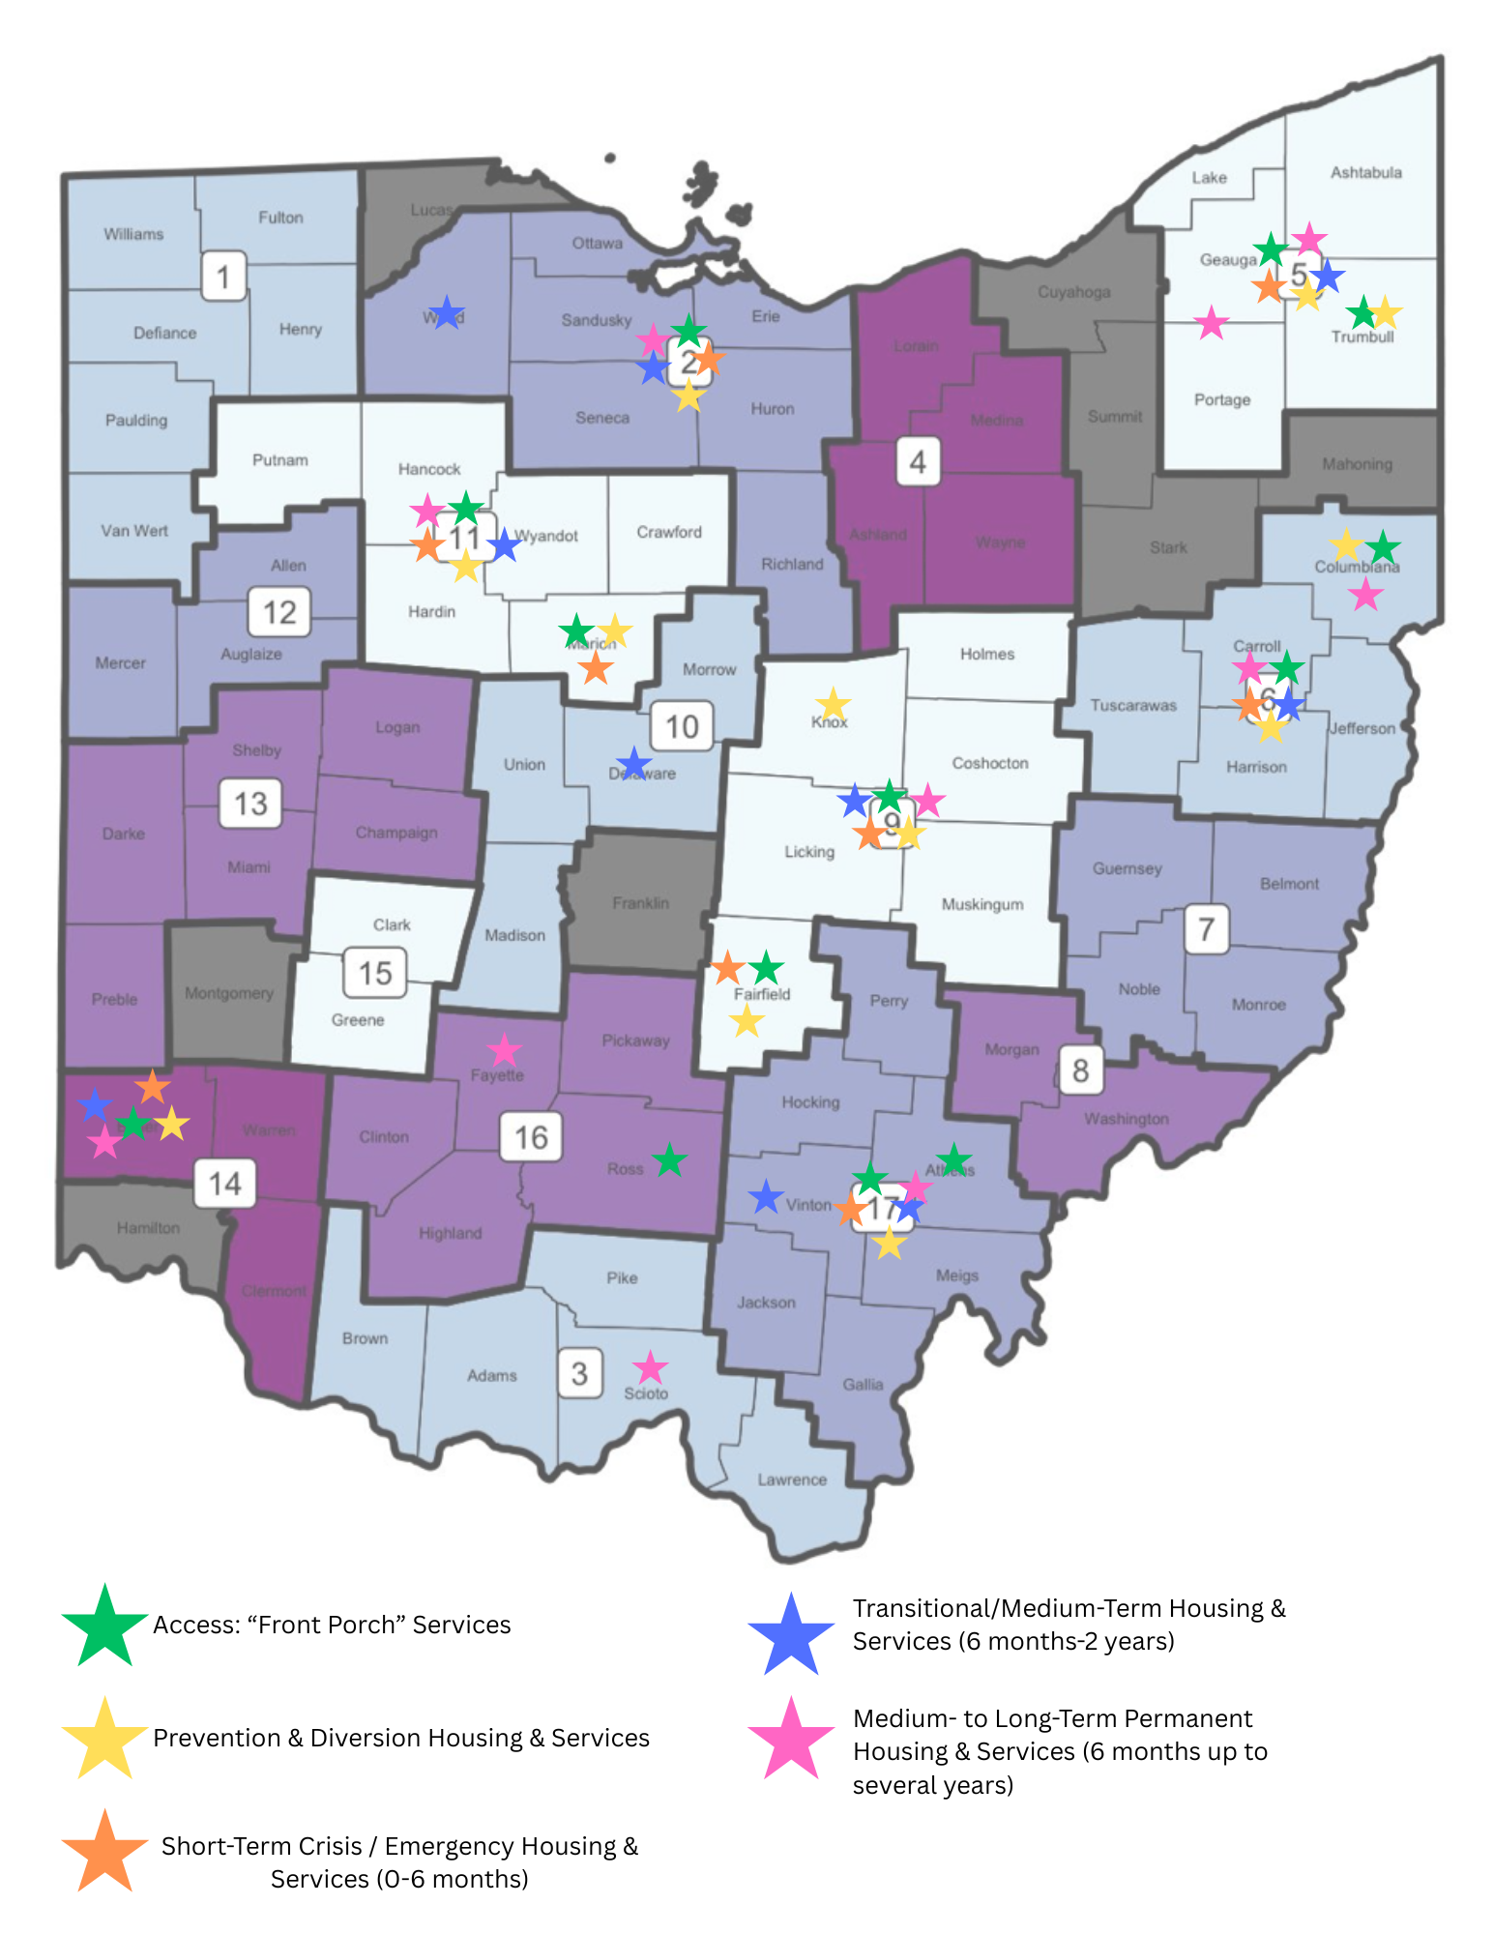
Note: statewide resources that serve all counties such as CCMEP, YNN, etc. are not listed on this map but are categorized in the table below.

→Housing Journey | Front Porch | Prevention/ Diversion | Crisis/Short-Term | Medium Term | Medium-Long Term
↓Youth-Dedicated Resources by Category
Child Welfare/ Foster Care | YNN | YNN  Ohio ETV | Ohio ETV | Bridges | Bridges
Coordinated Entry
Developmental Disabilities
Healthcare/ODH  (Funded through ODH) | ODH  -Columbiana HP  -Columbiana SSO  -LFCAA HASFY  -Trumbull - Urban League - A Safe Space | ODH  -Columbiana HP  -Columbiana SSO  -LFCAA HASFY  -Marion Goodwill  -Trumbull - Urban League - A Safe Space | ODH  -LFCAA Emergency Shelter Overflow  -Marion Goodwill |  | ODH  -Columbiana RRH  -Fayette CAC TAY-RRH  -F&CS Next Step
Higher Ed/Post-Secondary |  | Ohio REACH | Ohio REACH
Housing Provider/  Housing Authority  (HUD/CoC/ESG funding) | YHDP SSO:  -Columbiana  -BCESC  -F&CS  -GLCAP  -LFCAA  -Sojourners  -The Hive  Sojourners  -Drop-in Center  -Resiliency Center  -Youth Outreach  -Youth Build | YHDP SSO:  -Columbiana  -BCESC  -F&CS  -GLCAP  -LFCAA  -Sojourners | -Sojourners Ross County Transitional Housing  YHDP TH  -Columbiana  -Sojourners  -BCESC  -F&CS  -GLCAP  -LCCH | -Sojourners Vinton TH/TLP  YHDP RRH  -Columbiana  -BCESC  -F&CS  -GLCAP  -LCCH  -ISBH | -FUP Voucher  -FYI Voucher  PSH  -Hisle Park  -Sojourners  YHDP RRH  -Columbiana  -BCESC  -F&CS  -GLCAP  -LCCH  -ISBH
Justice/Re-entry
K-12 Education | M-V Liaisons | M-V Liaisons
Legal
Mental Health | 9-8-8 | -Freedom Center |  | Wood Co Harbor TIP House
Multi-System Youth/ Wraparound | -FCFC  -Ohio RISE | -FCFC  -Ohio RISE
Other | 2-1-1 | 2-1-1 |  | Delaware Co Tree House TLP
SOAR/SSI
SUD/Treatment
System Coordination/CoC | BoSCoC Staff  BoSCoC YAB | BoSCoC Staff  BoSCoC YAB
Transportation
Workforce Development | CCMEP | CCMEP

Program Models Overview
When thinking on a systems level, we often put program types and models into the following broad housing/service categories:
- Access: “Front Porch” Services: These services are provided to people before they reach the front door of the homeless services system (the “front door” being the shelter system). They may be provided to people already experiencing homelessness or who are at imminent risk of homelessness.
- Prevention & Diversion Housing & Services: These interventions are intended to prevent or quickly divert people from entering the homeless system.
- Short-Term Crisis / Emergency Housing & Services (0-6 months): These interventions are intended to be time-limited and are designed to be a stepping-stone to stability. They typically last 1 to 6 months and provide supportive, holistic, youth-specific services that aim to lead to long-lasting housing stability. Services should be flexible, client-centered, trauma-informed, and strengths-based. They are low-barrier in that they will not kick people out of programming due to their specific behaviors or choice not to participate in specific services or activities.
- Transitional/Medium-Term Housing & Services (6 months-2 years): This type of housing and services is meant to provide safety and stability in a temporary setting, meaning that the client likely cannot stay there forever on their own, they typically have an occupancy agreement or temporary lease/boarding agreement (e.g., a host home or transitional housing unit). They typically last 6 to 24 months and provide supportive, holistic, youth-specific services that aim to lead to long-lasting housing stability. Services should be flexible, client-centered, trauma-informed, and strengths-based. These settings provide supportive services and housing assistance to support people in returning to independent permanent housing or permanent housing supported by a mainstream system resource.
- Medium- to Long-Term Permanent Housing & Services (6 months up to several years): Safe and stable housing in a permanent housing setting, meaning that the client has a lease in their own name (e.g. RRH, PSH, FYI) or are residing in a location that does not have a time limit (e.g., PSH). They typically last for at least 6 months and, depending on the model and funding allowances, can last for several years. They provide supportive, holistic, youth-specific services that aim to lead to long-lasting housing stability. Services should be flexible, client-centered, trauma-informed, and strengths-based. These settings provide services and housing assistance to support people in obtaining permanent housing and staying housed, either independently or supported by a mainstream system resource.

Key Takeaways: Essential Elements from Ohio YHSI System Mapping/Modeling Planning & Brainstorming Session(s)
During the August 28, 2025 YHSI planning meeting, people said they want to see the following implemented in the youth homelessness system in the Balance of State.

Possible New or Expanded Types of Housing
- Example: More crisis housing options with more models. Ideally, crisis housing is always available.
- HP for YYA allocated regionally
- More affordable housing
- Safe housing for YYA
- Intentional PH/YYA placement
- Funding source(s) for Ross Transitional Housing
- PHA YYA-dedicated vouchers
- Analyze existing PSH and redistribute to YYA when underutilized
- Increase YYA PSH
- Increased YYA-dedicated C-TH modeled from Region 17

Possible New or Expanded Services
- Example: Prevention, Outreach/drop-in, and diversion funding
- YYA-dedicated eviction prevention
- YYA childcare service integration
- Financial security for YYA
- Independent living skills for YYA
- Early financial education for YYA
- Identify providers to serve YYA under 18
- Addressing gaps due to funding restrictions

Essential program elements:
- Examples: Pets need to be allowed, safer, open-minded, learn about one another’s identities and cultures, quick access to mental health support, etc.
- YYA-focused landlord training/education
- More staff training in YYA programs
- YYA appropriate agency policies and procedures
- Better understanding of YYA Head of Household make-up
- Better analysis of YYA income
- Better monitoring of YYA programs
- YYA length-of-stay in PH considerations (36 months?)
- Identify and motivate providers to serve YYA
- Re-think prioritization for YYA
- Working with adult corrections; juvenile justice requirements shouldn’t cause homelessness
- Homelessness training for PCWAs

Specific services:
- Example: Consistency and continuity – standards of practice for youth services across the system
- Cross-system coordination
- Cross-system communication
- Front porch coordination

Selected regions within the Ohio BoSCoC were awarded Youth Homelessness Demonstration Program (YHDP) funding in Rounds, 1, 3, and 7. As part of those awards, the communities within the award sites developed Coordinated Community Plans that include objectives, goals, and action plans to prevent and end youth and young adult homelessness. These plans are available on the COHHIO website: Round 7 (2024) https://cohhio.org/wp-content/uploads/2024/11/Youth-Lead-The-Way-CCP-Ohio-Balance-of-State-Round-7.pdf Round 3 (2020) https://cohhio.org/wp-content/uploads/2020/05/Region-6-YHDP-CCP.pdf Round 1 (2018) https://cohhio.org/wp-content/uploads/2018/04/FINAL-SEOH-YHDP-CCP-optimized.pdf

